Name:___________________________________ Unit 1 - Introducing GSP
Monica
Geometry Period:____
Date:____________________________

Directions Part I: In this activity, you will experiment with drawing, dragging, measuring, and labeling points, segments, rays, and lines. These objects, along with circles, are the building blocks of most geometric constructions. Use the results from your investigation to answer the questions.

Sketch and Investigate: Introducing Points, Segments, Rays, and Lines

Note: If at any time you think you’ve made a mistake or you want to do something differently, you can always undo as many steps as you like. The Undo and Redo commands are in the Edit menu.
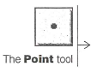
- Choose the point tool and click in the sketch to construct a point. Click again to construct a second point. Notice that the most recently constructed point is selected: It appears with an outline.
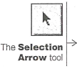

- Choose the Selection Arrow tool and click in a blank area in the sketch. This deselects everything.
- Choose the Text tool. Position the finger over a point, then click to display that point’s label. Display the other point’s label, too.
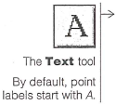

- With the Selection Arrow tool, click on both points. Now both points should be selected.
- In the measure menu, choose Distance.

- Drag one of the points and observe the measurement.

QUESTION #1: How can you make the distance between the two points zero?

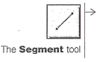
- Choose the Segment tool and draw a segment
connecting the two points. You’ll see a triple segment at first,
indicating that the segment is selected.

- With the segment selected, go to the Measure menu and choose Length.

- Use the Selection Arrow tool to drag either endpoint of the segment.

QUESTION #2: How does the length of a segment compare to the distance between its endpoints? How does the notation compare?

- Use the Segment tool to construct a second segment
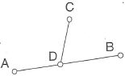
with one endpoint attached to the first segment. To do this,
click the mouse button first when the pointer is in a blank area
of the sketch, then when it’s directly on the original segment.

- Use the Text tool to show the labels of this segment’s endpoints.

- Use the Selection Arrow tool to drag point D to confirm that it is attached to.

- Select (the segment, not its endpoints), then go to the Construct menu and notice what choices are available. Choose Midpoint.

- Click in a blank area to deselect everything.

- Select point D.

- In the Edit menu, drag to the Action Buttons submenu and choose Animation. You’ll get a dialog box you can use to specify animation settings. To choose the default settings, click OK. You’ve created an Animation action button in your sketch.
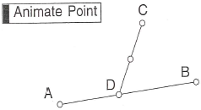

- Press the action button (by clicking on it) to start the animation.

- Press the button again to stop the animation.

- Select the midpoint; then, in the Display menu, choose Trace Midpoint.

- Press the Animation button again and observe the path that the midpoint traces.

QUESTION #3: Describe the path the midpoint traces as point D moves back and forth. Use precise mathematical language. Why does this happen?

- In the File menu, choose New Sketch.
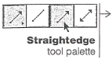
- Press and hold down the mouse button on the Segment tool. A palette of Straightedge tools will pop out to the right. Drag right and choose the Ray tool.
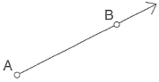

- Draw a ray in your sketch. Notice that the ray extends
in one direction beyond the edge of your sketch window.

- Use the Text tool to show the labels of the ray’s control points.

- Use the Selection Arrow tool to drag each point to observe how it controls the ray.

QUESTION #4: A ray with endpoint A that passes through a point B is called ray AB (represented symbolically as ). Could it also be called ray BA? Explain why or why not.

- Select the ray and go to the Measure menu. Note that Length is grayed out.

QUESTION #5: Why do you think you can’t measure the length of a ray?

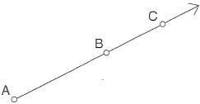

- With the ray still selected, go to the Construct menu and
look at your choices. Choose Point On Ray.

QUESTION #6: Why can’t you construct the midpoint of a ray?

- Drag this new point to see how its behavior compares to that of the ray’s two control points.

QUESTION #7: Give two different names to the ray shown below. Use just two points in each name.
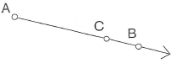

- Press and hold down the Ray tool, then drag right to choose the Line tool.

- Experiment with drawing lines in your sketch.

QUESTION #8: List all the similarities and differences you can between segments, rays, and lines.

QUESTION #9: Name the line below in two different ways. Name two rays and a segment that lie on the line.

QUESTION #10: In Sketchpad, construct a line without using the Line tool. Explain what you did. Does your line remain a line when you drag the points?

Directions Part 2: An angle is sometimes defined as two rays that share an endpoint. But two segments with a common endpoint also determine an angle. And we usually name an angle after three points. If that’s not confusing enough, angle measure is usually considered something different from an angle. In this activity, you will explore angles and angle measures with Sketchpad.

Sketch and Investigate: Introducing Angles

- In the Edit menu, choose Preferences. Set the angle unit to degrees with precision to the nearest tenth.
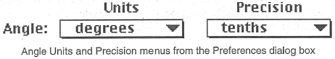
- Use the Ray tool to construct.
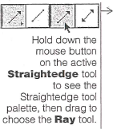

- Construct another ray,, with the same endpoint A.
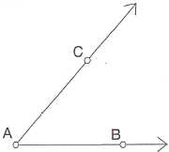
- 4. Drag each of the three points to make sure the two rays always
share a common endpoint (point A).
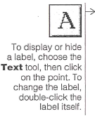
- 5. If necessary, use the Text tool to display the point labels.
Change them to match the figure to the right.

QUESTION #1: Two rays with a common endpoint form an angle. The common endpoint of the rays is called the vertex of the angle. Name the vertex of the angle you just made.

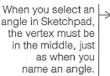
- 6. Select, in order, points B, A, and C; then, in the Measure menu, choose Angle.
- Drag point B or point C and observe how the angle measure changes.

QUESTION #2: Angles are often named after three points: a point on one side, the vertex, and a point on the other side. If an angle is not adjacent to another angle, as it is in this case, we can name it by its vertex alone. What are three possible names for the angle you just made?

QUESTION #3: What’s the smallest angle measure you can make by dragging? What’s the greatest?

QUESTION #4: Drag a point on your angle until the angle’s measure is as close to 0° as possible. Describe this angle.

QUESTION #5: Drag a point on your angle until the angle’s measure is as close to 90° as possible. Describe this angle. What is the name of this angle?

QUESTION #6: Drag a point on your angle until the angle’s measure is as close to 180° as possible. Describe this angle. What is the name of this angle?

QUESTION #7: An acute angle has measure between 0° and 90°. Drag a point on your angle to make it acute. Sketch an example of an acute angle in the space below.

QUESTION #8: An obtuse angle has measure between 90° and 180°. Drag a point on your angle to make it obtuse. Sketch an example of an obtuse angle in the space below.

- Using the Circle tool, draw a circle centered at point A but not attached to any other points in your sketch.

- Select the circle and point C; then, in the Edit menu,
choose Merge Point To Circle. Point C will attach itself to the circle.
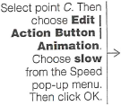
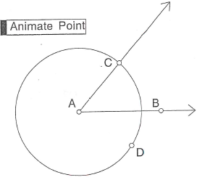

- Make an action button to animate point C around the circle.

- Press the button (click on it, in other words) to play it.
Watch the angle measurement during the animation.
(Press the button again to stop the animation.)

QUESTION #9: With Preferences set to degrees, Sketchpad displays angle measures from 0° to 180°. So when one angle side rotates by more than one-half of a revolution from the other angle side, the angle measure starts to decrease. Suppose the angle measure kept increasing until the angle side had completed one whole revolution. What would be the largest angle measure? Explain.

QUESTION #10: Draw an angle using the Segment tool. Does the measure of the angle depend on the lengths of the sides? Explore this question in Sketchpad, then explain below.

