Name:______________________________________________ **Unit 1 – Practice with Proofs and Angles**

Monica

Geometry Period:_____

Date:________________________________

**Directions:** For questions 1 – 3, determine the value of the variable. You must show all of your work in order to receive full credit. If necessary, write your answers in simplest radical form.

1) Line *m* is drawn in the diagram below. Determine the value of x.

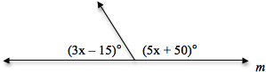

2) Lines *k* and *n* are intersecting below. Determine the value of *y.*

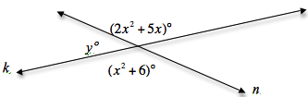

3) In the diagram below,  Determine the measure of 

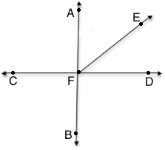

**Directions:** For questions 4 – 5, write a convincing argument (proof) to show the statement is true. Be sure to provide correct statements with appropriate corresponding reasons that justify each step.

4) In the diagram below, it is given that  Prove that .

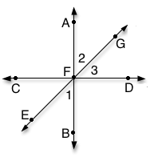

5)

