Name:___________________________________ **Unit 2 – Deriving the Distance Formula**

Monica

Geometry Period:____

Date:____________________________________

**Directions:** For each of the questions below:

1. Identify the coordinates of points A, B, and C
2. Determine the lengths of AB and CA
3. Use the Pythagorean Theorem to determine the length of BC (If necessary, write your answer in simplest radical form.)

1)

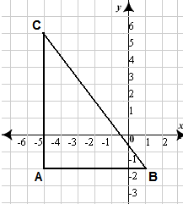

Coordinates of A:__________ Length of AB = ______________

Coordinates of B:__________ Length of CA = ______________

Coordinates of C:__________ Length of BC = ______________

2)

Coordinates of A:__________ Length of AB = ______________

Coordinates of B:__________ Length of CA = ______________

Coordinates of C:__________ Length of BC = ______________

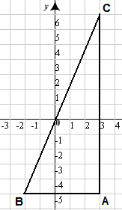

3)

Coordinates of A:__________ Length of AB = ______________

Coordinates of B:__________ Length of CA = ______________

Coordinates of C:__________ Length of BC = ______________

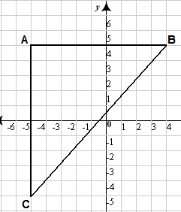

4) Look back at the y-coordinates for points A and B for questions 1 – 3. What do you notice about their y-coordinates? Why did this happen? What is the relationship between the x-coordinates and the length of the segments?

5) Look back at the x-coordinates for points A and C for questions 1 – 3. What do you notice about their x-coordinates? Why did this happen? What is the relationship between the y-coordinates and the length of the segments?

6) How did you find the length of AB and CA in questions 1 – 3? How could you have used just the coordinates to find the length of these segments?

7) The diagram below represents all of the questions you just answered. Determine the length of CB the same way you did for questions 1 – 3.

1. Identify the coordinates of points A, B, and C
2. Determine the lengths of AB and CA (in this case you will represent the lengths as an algebraic expression. If you’re unsure how to do this, think back to your answer in #5.)
3. Use the Pythagorean Theorem to determine the length of BC (again, the length will be represented as an algebraic expression)

Coordinates of A:________ Length of AB = _______________________

Coordinates of B:________ Length of CA = _______________________

Coordinates of C:________ Length of BC = _______________________

**C** 

**A**

**B** 

8) Test it out! The algebraic expression you derived for the length of BC in question #7 is the distance formula! It can be used to determine the distance between any two points on a coordinate plane. What is the length (distance between the two points) of a segment whose endpoints are (-4, 3) and (6, -2)? Write your answers in simplest radical form.