Names:___________________________________________________ Unit 2 – Equations of Monica Perpendicular Bisectors
Geometry Period:_____
Date:____________________________

Directions: As a group, answer the questions below. Show all work on this paper, but you should also keep notes in your notebook.

1) A segment is drawn on the coordinate plane below. Determine the equation of the perpendicular bisector to the segment. Then graph that line.

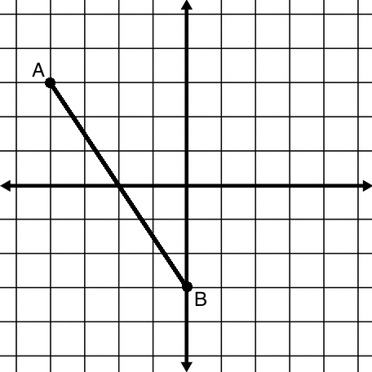

2) What steps were necessary to determine the equation of the perpendicular bisector? Write them below (and in your notebook!).

3) Pick two different points that fall on the line of the perpendicular bisector. Label them C and D. Determine the distance of CA and CB, and DA and DB.

4) What did you notice about your answers in question #3? Write a conjecture about the distance of any given point on a perpendicular bisector to the endpoints of the bisected segment.

