Name:___________________________________________ **Unit 3 Review**

Monica

Geometry Period:_____

Date:_______________________________________

**Directions:** The questions below are designed to help prepare you for the exam tomorrow. The questions are separated by outcome. Answers can be found online. Be sure to ask for help if there is anything you do not understand!

**#4: Determines and uses the length and midpoint of a segment AND #5: Graphically and algebraically discerns if lines are parallel or perpendicular on a coordinate plane and can identify the point of intersection of intersecting lines**

1) The graphs below show pre-image and image points after a reflection. Determine the equation of the line of reflection.

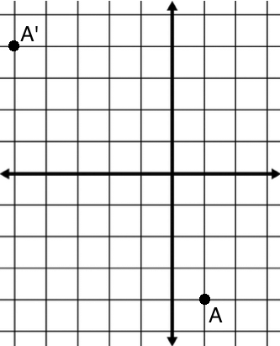 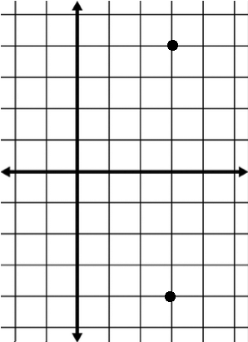

2) Reflect point A over the line shown on the graph below. Verify that your image point is correct by showing that the line is the perpendicular bisector.

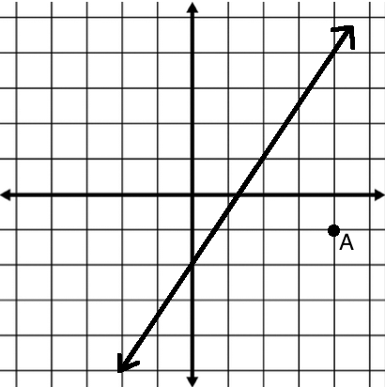

**#12: Applies and justifies properties of transformations and concepts of symmetry**

3) Graph on the coordinate plane below in the interval . Label it *a*. Sketch the image of the graph under the transformation . Label it *b*.

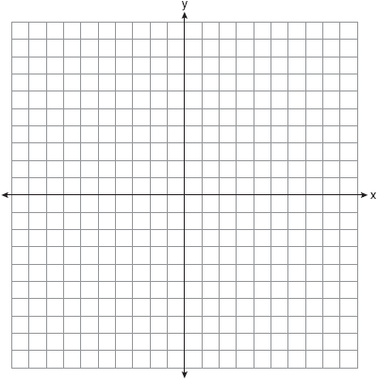

4) Identify the transformations that have taken place on each graph below. Identify the graphs that are isometric (direct or opposite).

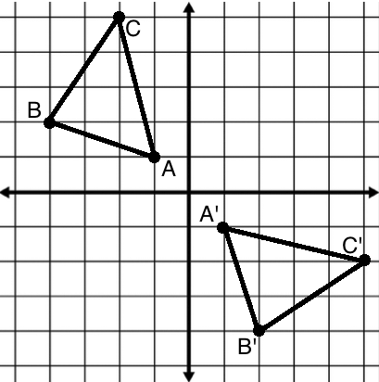 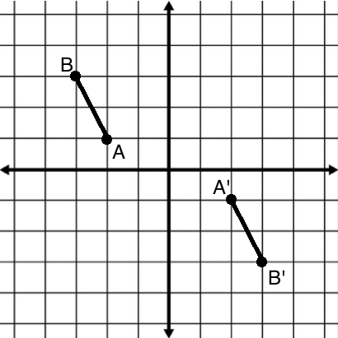 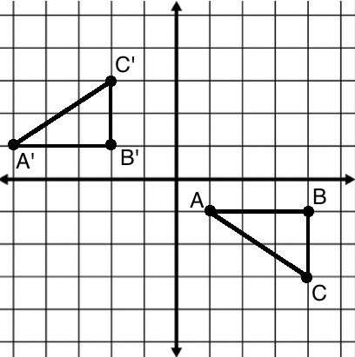 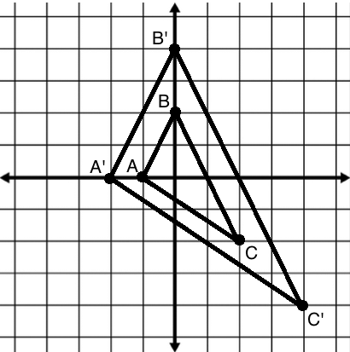

5) Given: *F* is the transformation 

*U* is the transformation 

*N* is the transformation 

The coordinates of  are A(1, 2), B(4, 0) and C(3, -2).

a. Sketch  and its image  after the transformation *F*.

b. Sketch  , the image of  after the transformation *U*.

c. Sketch , the image of  after the transformation *N*.

d. Identify each transformation for a, b, and c (reflection, rotation, translation, dilation).

e. Which transformations are isometries?

f. For the transformations you identified as an isometry, identify it as direct or opposite.

