Name:__________________________________________ **Unit 3 – Transformation Notes**

Monica

Geometry Period:____

Date:_______________________________________

|  |  |
| --- | --- |
|  | **RULES OF TRANSFORMATIONS** |
| **REFLECTIONS** | If a point  is reflected over the **y – axis**, the new coordinates will be ______________. |
| ***Example:*** *If (3, -4) is reflected over the y-axis, the new coordinates will be ______________.* |
| If a point  is reflected over the **x –axis**, the new coordinates will be ____________. |
| ***Example:*** *If (3, -4) is reflected over the x-axis, the new coordinates will be ______________.* |
| If a point  is reflected over the line **x = a**, the new coordinates will be ____________. |
| ***Example*:** If (3, -4) is reflected over the line x = a, the new coordinates will be ______________. |
| If a point  is reflected over the line **y = a**, the new coordinates will be ____________. |
| ***Example:***  *If (3, -4) is reflected over the line y = a, the new coordinates will be ______________.* |
| If a point  is reflected over the line **y = x**, the new coordinates will be ____________. |
| ***Example:*** *If (3, -4) is reflected over the line y = x, the new coordinates will be ______________.* |
| If a point  is reflected over the line **y = -x**, the new coordinates will be ____________. |
| ***Example:***  *If (3, -4) is reflected over the line y = -x, the new coordinates will be ______________.* |
| **ROTATIONS** | If a point  is **rotated about the origin 90°**, the new coordinates will be ____________. |
| ***Example:*** *If (3, -4) is rotated about the origin 90°, the new coordinates will be ______________.* |
| If a point  is **rotated about the origin 180°**, the new coordinates will be ____________. |
| ***Example:*** *If (3, -4) is rotated about the origin 180°, the new coordinates will be ______________.* |
| If a point  is **rotated about the origin 270°**, the new coordinates will be ____________. |
| ***Example:*** *If (3, -4) is rotated about the origin 270°, the new coordinates will be ______________.* |
| **DILATIONS** | If a point  is **dilated about the origin by a scale factor of *k***, the new coordinates will be ___________. |
| ***Example:*** *If (3, -4) is dilated about the origin by a scale factor of 2, the new coordinates will be _________.* |
| **TRANS-LATIONS** | If a point  is **translated *a* units horizontally and *b* units vertically**, the new coordinates will be ___________. |
| ***Example:*** *If (3, -4) is translated by (x – 4, y + 6), the new coordinates will be _________.* |

Put a check in each box to show which properties remain invariant (the properties that are preserved or unchanged).

|  |  |  |  |  |
| --- | --- | --- | --- | --- |
| **TRANSFORMATION** | **Preserves Orientation** | **Preserves Length** | **Preserves Angle Measures** | **Isometry**  **(Direct or opposite?)** |
| **Reflection** |  |  |  |  |
| **Rotation** |  |  |  |  |
| **Translation** |  |  |  |  |
| **Dilation** |  |  |  |  |

A transformation is considered an ***isometry***if it preserves length. A **direct isometry** preserves orientation and an **opposite isometry** does not preserve orientation. After completing the chart above, identify which transformations are *isometric*, and identify which type of isometry it is by completing the last column.

1) The coordinates of the vertices of  are  Graph ansd state the coordinates of , the image of  after a rotation of 90° about the origin.

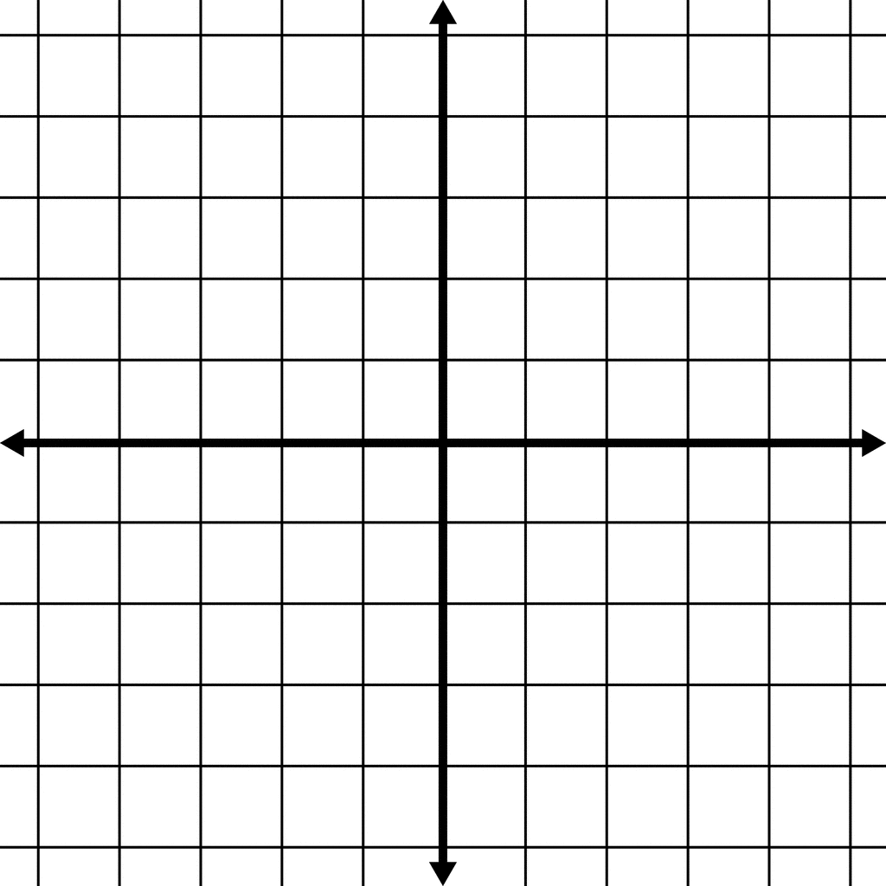

2) Triangle *XYZ*, shown in the diagram below, is reflected over the line x = 2. State the coordinates of, the image of .

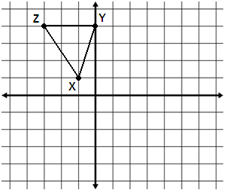

3) As shown in the diagram below, quadrilateral ABCD was transformed to create image A’B’C’D’. There are no coordinates to identify the points. What type of transformation must have taken place? Why?

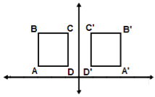

4) Triangle ABC went through a transformation took preserved the slope of each side but did not preserve the length. What type of transformation must have taken place? Why?

5) All of the reflections we’ve examined so far have been over a line. Considering what you know about reflections, what would be the image of (-2, 3) if it was reflected over the origin, (0, 0)? What would be the image of the point (*x, y*) if it was reflected over the origin? Explain how you arrived at your answer.

6) Point A was reflected over the line y = x to create the image point A’. Then, point A’ was rotated 90° about the origin to create the new image point A’’. What single transformation could transform point A to point A’’? Explain how you arrived at your answer. [The use of the grid below is optional.]

