Name:_________________________________________ **Unit 3 – Composition of Transformations**

Monica

Geometry Period:____

Date:______________________________

**Directions:** All of the questions below are old Regents questions (except #5). Read each question carefully and answer the question being asked! You must show all of your work in order to receive a MS rating.

1) Which transformation is equivalent to the composite line reflections  ?

|  |  |
| --- | --- |
| 1) | a rotation |
| 2) | a dilation |
| 3) | a translation |
| 4) | a glide reflection |

2) Write a single translation that is equivalent to  followed by  .

3) Triangle *ABC* has coordinates *A*(-1, 2), *B*(6, 2), and *C*(3, 4).

*a* On the grid below, draw and label *.*

*b* Graph and state the coordinates of *,* the image of  after the composition 

*c* Write a transformation equivalent to 

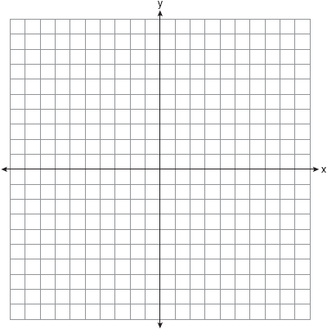

4) On the graph below, draw and label  , whose vertices are *P*(1, 2), *O*(3, 5), and *R*(4, -2). On the same set of axes, graph and state the coordinates of

*a* *,* the image of  after .

*b* *,* the image of  after  .

*c* *,* the image of  after  .

*d*  Is this composition of transformations an isometry?

*e* Was the orientation preserved?



5) On the grid below, graph any triangle ABC. Perform a glide reflection and write down the composition of transformations used to produce your image. Be sure to graph your image as well! Explain how you know it’s a glide reflection.

