Name:_________________________________ Unit 4 – Coordinate Plane and Points of Concurrency
Monica
Geometry Period:____
Date:____________________________

Directions: Answer all of the following questions. Correct answers with no work shown will receive a “NY” rating.

1) Triangle ABC has vertices A (3, 3), B (7, 9), and C (11, 3). Determine the point of intersection of the medians, and state its coordinates.

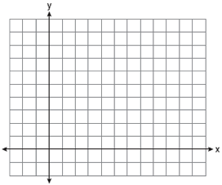

2) Find the center of the circle that you can circumscribe about triangle ABC if it has vertices A(1, 4), B(1, 2) and C(6, 2).

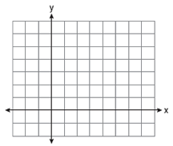

3) Determine the coordinates of the orthocenter in triangle ABC below.
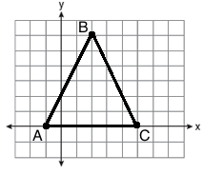

4) Use the space below to answer question #32 on page 278 from your textbook.

