Name:________________________________ Date:_______________

**BASIC CONSTRUCTIONS WITH A COMPASS AND A STRAIGHTEDGE**

**I. Duplicating a Segment**

STEPS:

1:

2:

3:

4:



**Ia. Constructing a Segment Twice as Long**

**II. Duplicating an Angle**

STEPS:

1:

2:

3:

4:

5:

6:

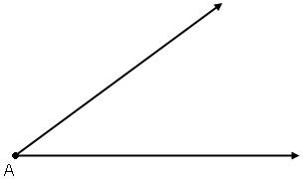

**IIa. Constructing an Angle Twice as large**

**III. Constructing a Perpendicular Bisector**

STEPS:

1:

2:

3:

4:





**IV. Constructing an Angle Bisector**

STEPS:

1:

2:

3:

4:

**

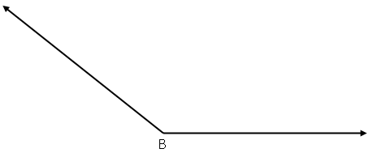

**V. Constructing an Equilateral Triangle**

STEPS:

1:

2:

3:

4:



Can you construct an isosceles triangle?



**VI. Constructing a parallel line through a point off a line**

STEPS:

1:

2:

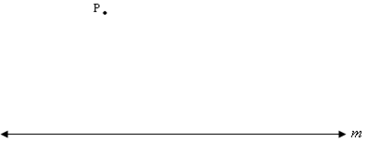

Question: Why must the two lines be parallel above?

**You try! Construct line *w* through point K so it is parallel to line *n.***

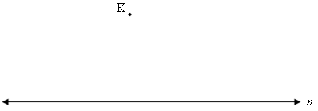

**VII. Constructing a Perpendicular through a given point ON a line**

STEPS:

1:

2:

3:

4:

5:



**You try! Construct so that  at point B.**

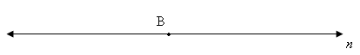

**VIII. Constructing a Perpendicular through a given point OFF a line**

STEPS:

1:

2:

3:

4:

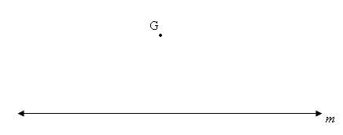

**You try! Construct so that .**

