Name:___________________________________ Unit 4 – GSP: Perpendicular and Angle Bisectors Monica
Geometry Period:_____
Date:___________________________

Directions: Use Geometer’s Sketchpad to complete the constructions below. Then answer the questions based on your constructions.
Step 1: Open Geometer’s Sketchpad.
Step 2: Draw segment AB.
Step 3: Construct the perpendicular bisector of AB by completing the following steps:
- Construct the midpoint of AB. (Select segment AB and choose “Midpoint” under the “Construct” menu.) Label this point M.
- Select the midpoint (M) and segment AB. Select “Perpendicular Line” under the “Construct” menu.
Step 4: Select the perpendicular line and select “Construct Point on Perpendicular Line” under the “Construct” menu. Label this point P.
Step 5: Measure the distance from point P to point A by selecting these points and choosing “Distance” under the “Measure” menu. Repeat this process with points P and B. Record your measurements below:
PA = ___________ PB = ___________

Step 6: Drag point P around and observe how the measurements change. (Drag points A and B as well.)

QUESTION #1: Complete the statement below based on what you observed.

If a point is on the perpendicular bisector of a segment, then it is ___________________________ from the endpoints of the segment.

Step 7: Open a new sketch by selecting “New Sketch” under “File.”
Step 8: Draw an angle by drawing two rays starting at the same point. Label your angle ABC with the vertex as B.
Step 9: Construct the angle bisector of angle ABC by selecting points A, B, and C (in that order) and selecting “Angle Bisector” under the “Construct” menu.
Step 10: Select the angle bisector and select “Point on Angle Bisector” under the “Construct” menu. Label this point D.
Step 11: Measure the distance from point D to each side of the angle. To do this, select point D and ray BA. Under the “Construct” menu select “Perpendicular Line.” Label the point of intersection as Y. Repeat this process with point D and ray BC. Label the point of intersection as Z.
Step 12: Measure the length of DY and DZ by selecting point D and point Y and selecting “Distance” under the “Measure” menu. Repeat this process for points D and Z. Record your measurements below:
DY = ___________ DZ = ___________

Step 13: Drag point D around and observe how the measurements change. (Drag points A and C as well.)
QUESTION #2: Complete the statement below based on what you observed.

If a point is on the bisector of an angle, then it is ___________________________ from the
sides of the angle.

QUESTION #3: Based on what you wrote in questions 2 and 3, complete the statements below.

- If a point is equidistant from the endpoints of a segment, then it is on the ____________________________________ of the segment.

- If a point in the interior of an angle is equidistant from the sides of the angle, then the point is on the ___________________________________.

QUESTION #4: Using the new information you just discovered, determine the value of x in each of the diagrams below. If there isn’t enough information, write “not enough information.”

a)  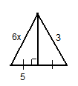 | b)  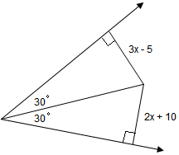 | c)  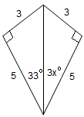
d)  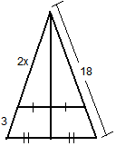 | e)  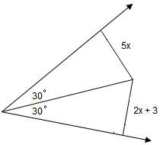 | f)  