Name: ______________________________ **Unit 5 – Polygon Angle Sums Investigation**

Monica

Geometry Period: ____

Date: ________________________

**Directions:** Today you are going to explore the sum of the interior angles of polygons. Use the chart on the next page to record your findings. The first two examples are done for you. (Note: The last column in the chart will be addressed later.) You will need to record the name of each shape. If you do not know the correct names, use the internet or your textbook to help you.

**PART 1:** What are the angle sums in polygons?

**STEP 1:** Use the segment tool to create a 5-sided figure, ABCDE. (Make sure your polygon is convex and not concave!) Measure each interior angle and determine the sum of all 5 angles. Record your findings in the chart on the next page. Do not delete your drawing.

**STEP 2:** Use the segment tool to create a 6-sided figure, ABCDEF. (Make sure your polygon is convex and not concave!) Measure each interior angle and determine the sum of all 6 angles. Record your findings in the chart on the next page. Do not delete your drawing.

**STEP 3:** Use the segment tool to create a 7-sided figure, ABCDEFG. (Make sure your polygon is convex and not concave!) Measure each interior angle and determine the sum of all 7 angles. Record your findings in the chart on the next page. Do not delete your drawing.

**STEP 4:** Use the segment tool to create a 8-sided figure, ABCDEFGH. (Make sure your polygon is convex and not concave!) Measure each interior angle and determine the sum of all 8 angles. Record your findings in the chart on the next page. Do not delete your drawing.

**STEP 5:** Use the segment tool to create a 9-sided figure, ABCDEFGHI. (Make sure your polygon is convex and not concave!) Measure each interior angle and determine the sum of all 9 angles. Record your findings in the chart on the next page. Do not delete your drawing.

**STEP 6:** Use the segment tool to create a 10-sided figure, ABCDEFGHIJ. (Make sure your polygon is convex and not concave!) Measure each interior angle and determine the sum of all 10 angles. Record your findings in the chart on the next page. Do not delete your drawing.

**STEP 7:** Use the segment tool to create a 12-sided figure, ABCDEFGHIJKL. (Make sure your polygon is convex and not concave!) Measure each interior angle and determine the sum of all 12 angles. Record your findings in the chart on the next page. Do not delete your drawing.

**QUESTION #1:** Was the sum of the interior angles for each shape the same? Do you notice a relationship between the number of sides and the total number of degrees? If so, what is it?

|  |  |  |  |  |
| --- | --- | --- | --- | --- |
| **PART 1** | | | | **PART 2** |
| **# of Sides** | **Name of Shape** | **Sketch** | **Sum of interior angles** | **Number of Triangles** |
| 3 | Triangle |  |  |  |
| 4 | Quadrilateral |  |  |  |
| 5 |  |  |  |  |
| 6 |  |  |  |  |
| 7 |  |  |  |  |
| 8 |  |  |  |  |
| 9 |  |  |  |  |
| 10 |  |  |  |  |
| 12 |  |  |  |  |

**PART 2:** Where do the angle sums come from?

**STEP 8:** Go back to the drawing of your 5-sided figure. Using the segment tool, connect point A to each of the other vertices. Count the number of triangles this created inside of your figure. Record this number in the last column in your chart. Sketch your findings on your figure in your chart.

**STEP 9:** Repeat this same process for the 6, 7, 8, 9, 10, and 12 sided figures. Record your findings in the last column in your chart.

**STEP 10:** Repeat this process by hand for the quadrilateral in your chart. Record your findings in the last column in your chart.

**QUESTION #2:** Examine the relationship between the number of sides for each figure and the number of triangles within each figure. What do you notice?

**QUESTION #3:** How many degrees are in a triangle? What role does this play in determining the total number of degrees in a polygon? (**HINT:** Knowing the number of degrees in a triangle, and the number of triangles used to form each polygon, look for a relationship between these two numbers and the sum of the interior angles.)

**QUESTION #4:** Write a rule that could be used to determine the total number of degrees in a polygon with *n* sides, where *n* represents any whole number greater than or equal to 3.

**QUESTION #5:** Using the rule you found in question #4 to help you, what is the sum of the interior angles of a polygon with 20 sides? Show your work.

**QUESTION #6:** A **regular polygon is a polygon with all equal sides and angles**. How would you determine the measure of ONE interior angle of a regular polygon? Use your rule to determine the measure of one interior angle in regular decagon.

**PART 3:** How can we apply what we’ve learned?

**Directions: Using what you found in today’s investigation, answer each of the questions below. Be sure to show all of your work!**

1) In the diagram below of regular pentagon *ABCDE, * is drawn. What is the measure of ? (Hint: What is the measure of  What properties does an isosceles triangle have?)

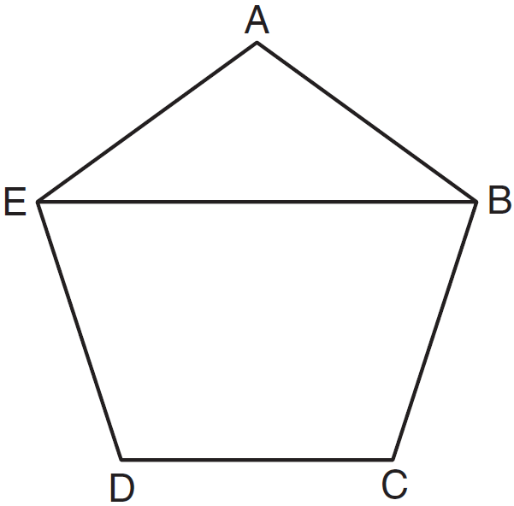

2) The measures of the interior angles of a quadrilateral are , , , and  What type of quadrilateral must this be? Why?

3) The measure of one interior angle of a regular polygon is 156**°.** How many sides does this polygon have? What is the name of a figure with this many sides?