Given: 

Prove: 

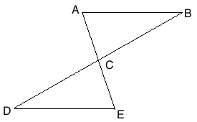

Given: 

Prove: 

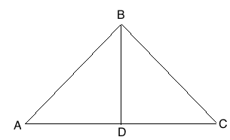

Given: 

Prove: 



Given: 

Prove: 

