DO NOT WRITE ON ME! RECORD YOUR ANSWERS IN YOUR NOTEBOOK. YOU CAN ACCESS THIS DOCUMENT ANYTIME ON MY WEB SITE.

1) In the diagram of and below, , , and .
Which method can be used to prove ?
1) | SSS
2) | SAS
3) | ASA
4) | HL

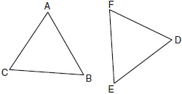

2) As shown in the diagram below, bisects and .
Which method could be used to prove ?
1) | SSS
2) | AAA
3) | SAS
4) | AAS

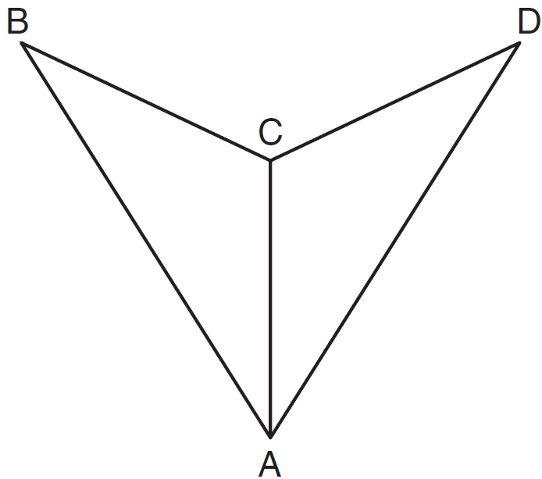

3) In the diagram below of and , , and .
To prove that and are congruent by SAS, what other information is needed?
1)
2)
3)
4)

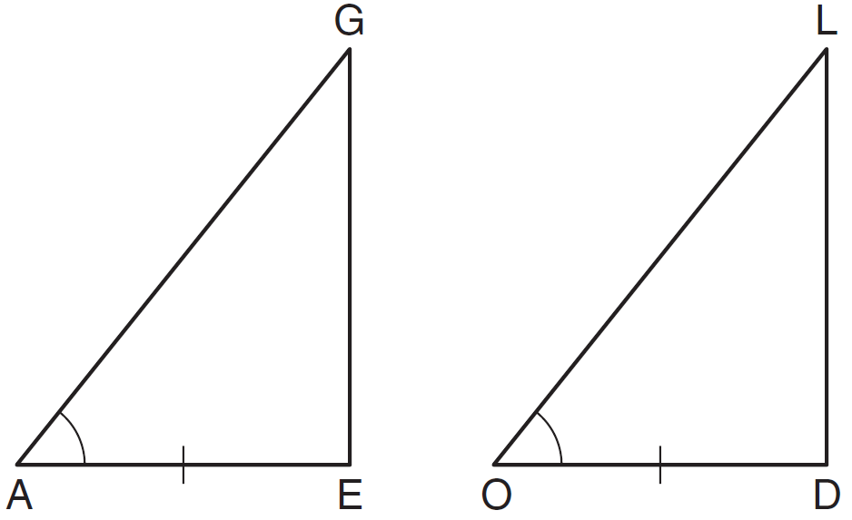

4) The diagonal is drawn in parallelogram ABCD. Which method can not be used to prove that ?
1) | SSS
2) | SAS
3) | SSA
4) | ASA

5) Which statements could be used to prove that and are congruent?
1)
2)
3)
4)

6) In the accompanying diagram of triangles BAT and FLU, and .
Which statement is needed to prove ?
1)
2)
3)
4)

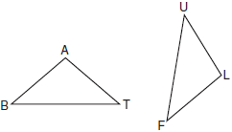

7) In the diagram below, .

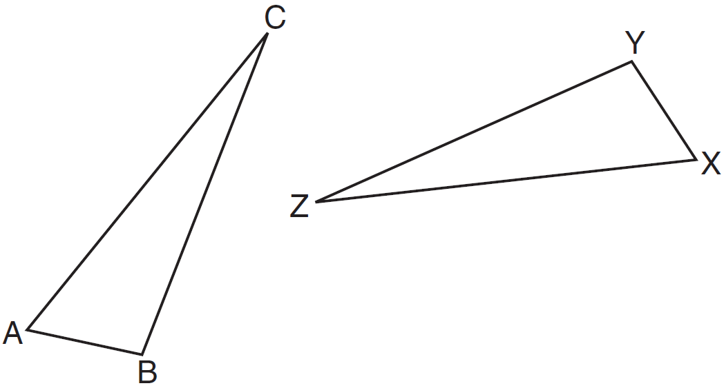
Which statement must be true?
1)
2)
3)
4)

8) The diagram below shows a pair of congruent triangles, with and .
Which statement must be true?
1)
2)
3)
4)

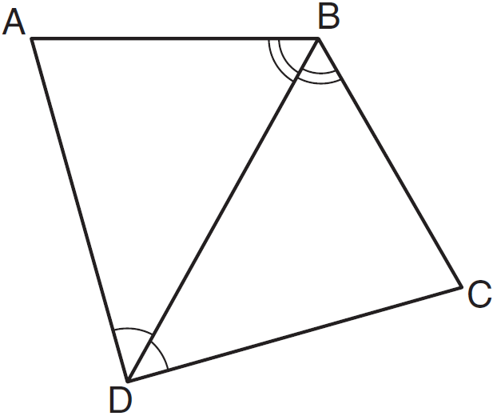

9) If , which statement is always true?
1)
2)
3)
4)

10) In the diagram below, .
Which two statements identify corresponding congruent parts for these triangles?
1)
2)
3)
4)

