Name:______________________________ Unit 6 – Practice with Proofs
Monica
Geometry Period:____
Date:______________________________

Directions: Complete the proofs below. You may use a paragraph proof, two-column proof, or flow chart proof.

1)
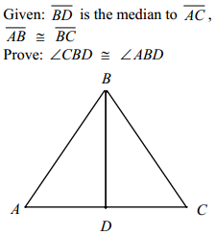

2)
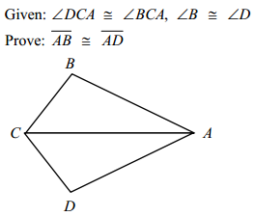

3)
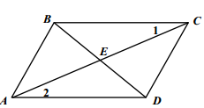

4)
