Name:___________________________________ **Unit 6 – Interior and Exterior Angles**

Monica

Geometry Period:_____

Date:___________________________________

**Directions:** All of the questions below require you to apply the Triangle Angle Sum Theorem or the Triangle Exterior Angle Theorem. You must show all of your work to receive full credit.

1) In the diagram of below, and . Line segment *MS* connects points *M* and *S* on the triangle, such that . What is ?

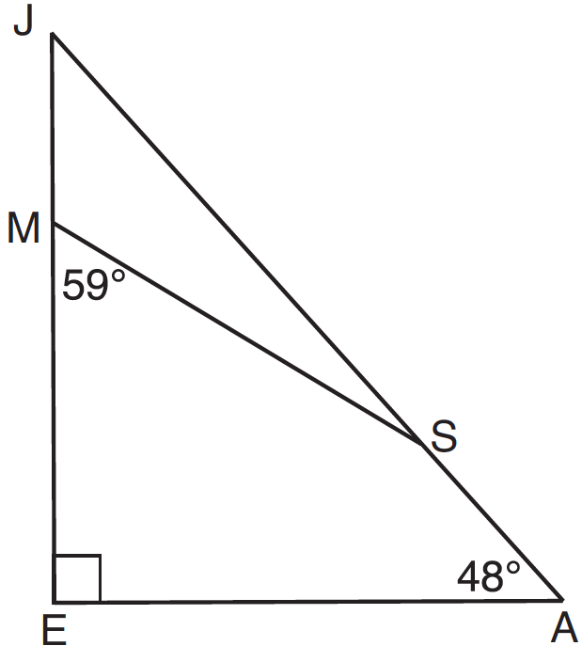

2) The diagram below shows , with , , and . If , what is ?

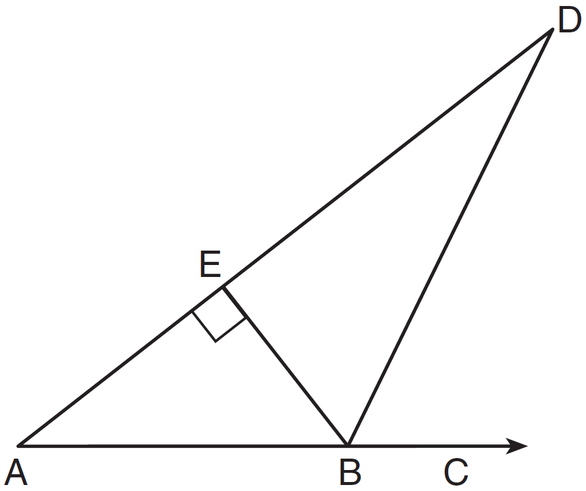

3) The angles of triangle *ABC* are in the ratio of 8:3:4. What is the measure of the *smallest* angle?

4) In ,  What is the value of *x*?

5) Juliann plans on drawing , where the measure of  can range from 50° to 60° and the measure of can range from 90° to 100°. Given these conditions, what is range of measures possible for ? Explain.

6) In , the measure of  is 21 less than four times the measure of , and the measure of  is 1 more than five times the measure of . Find the measure, in degrees, of each angle of .

7) In the diagram of  below, , , and is extended through *N*. What is the measure of?

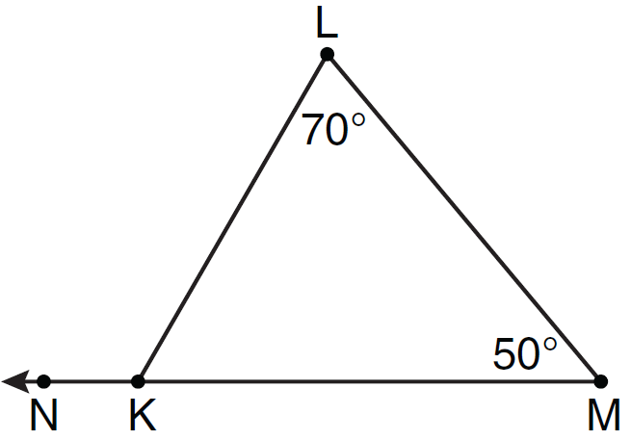

9) In , and an exterior angle at vertex *H* has a measure of 104. What is ?

10) In the diagram below of , side  is extended to point *D*, , , and . What is ?

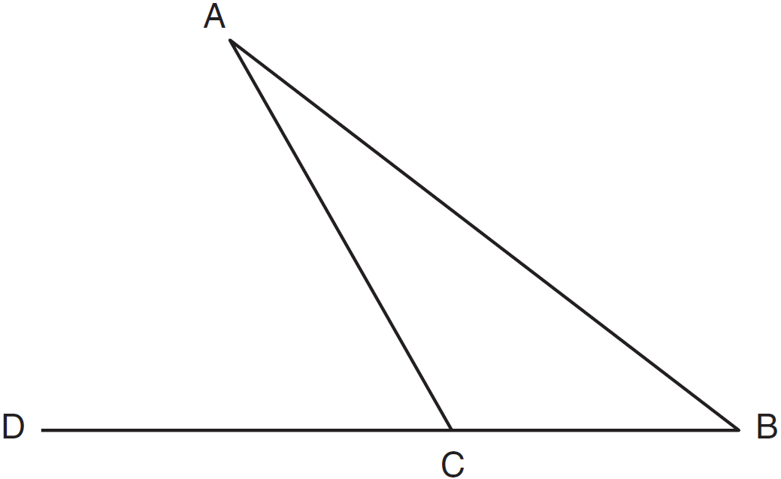

11) In the diagram below of , is extended to *D*. If , , and , what is the value of *x*?

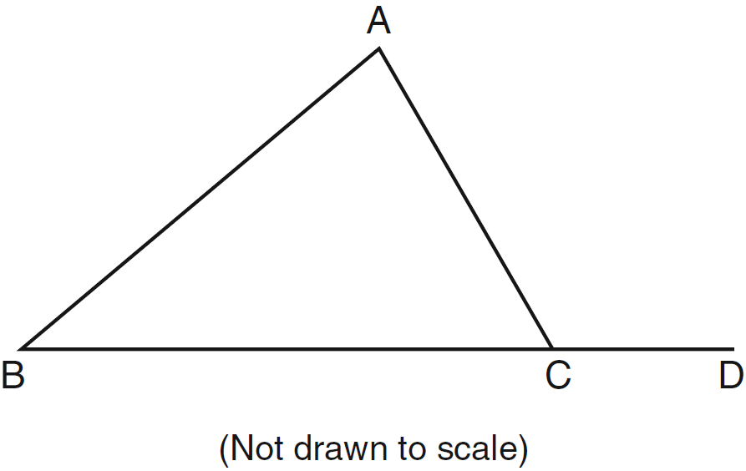

12) In the diagram below of , side  is extended to point *A*.

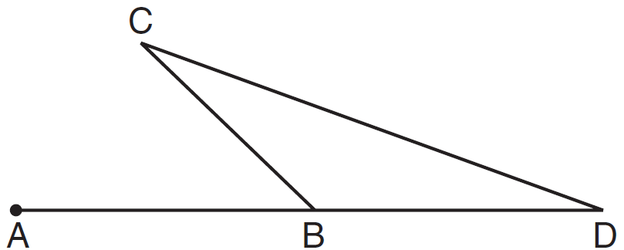

Which statement must be true? Why?

|  |  |
| --- | --- |
| 1) |  |
| 2) |  |
| 3) |  |
| 4) |  |