Name:__________________________________________ HW – Triangle Inequality
Monica
Geometry Period:______
Date:___________________________________________

Directions: Answer all of the questions below. You must show all of your work to receive full credit.

1) The plot of land illustrated in the accompanying diagram has a perimeter of 34 yards. Find the length, in yards, of each side of the figure. Could these measures actually represent the measures of the sides of a triangle? Explain your answer.

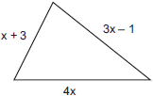

2) On the banks of a river, surveyors marked locations A, B, and C. The measure of and the measure of .

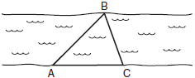

Which expression shows the relationship between the lengths of the sides of this triangle?
1)
2)
3)
4)

3) In scalene triangle ABC, and . What is the order of the sides in length, from longest to shortest?

1) | , ,
2) | , ,
3) | , ,
4) | , ,  As 4) 4) In the diagram of below, B is a point on and is drawn. If , , and , what is the longest side of ? Why?  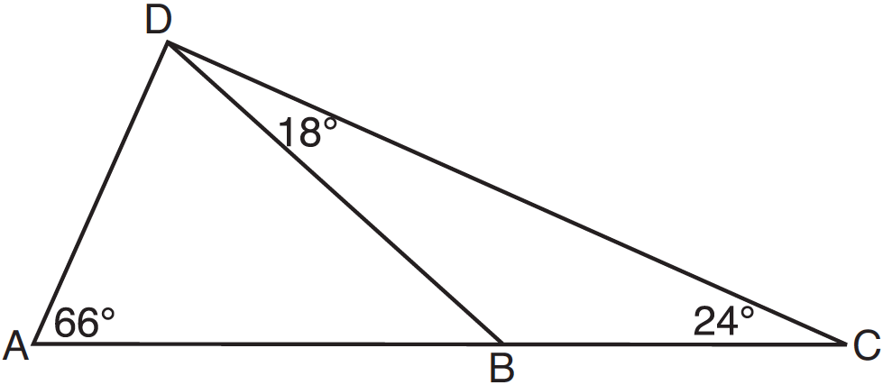  5) In , , , and . Determine the longest side of .

