Name:________________________________________ Unit 6 – Triangle Congruence Investigation
Monica
Geometry Period:____
Date:____________________________________

AIM: What is the minimum amount of information needed to prove that two triangles are congruent?

Part I Directions: Today you will be investigating the minimum conditions required to prove that two triangles are congruent. Go to my web site at geometry2014.weebly.com. Under “Unit 6 – Triangles” click on the link “Triangle Congruence Investigation Link” under Day 5. Complete the table below based on the questions asked and your answers. When you’re done, compare your answers with the other group at your table.

Triangle Congruence? | Sketch a Picture (Include given triangle and the triangle you manipulated) | Were the triangles congruent?
Side-Angle-Angle (SAA or AAS)
Side-Side-Angle (SSA or ASS)
Angle-Side-Angle (ASA)
Side-Side-Side (SSS)
Side-Angle-Side (SAS)
Angle-Angle-Angle (AAA)
Part II: Based on what you discovered, what is the minimum amount of information needed to prove two triangles are congruent? Write your findings in the form of conditionals. The first one is done for you.

1. If the three sides of one triangle are congruent to the three sides of another triangle, then the two triangles are congruent.

2. If two sides and the included angle of one triangle are congruent to two sides and the included angle

of another triangle, then ___________________________________________________________________.

3.

4.

Part III: Based on what you discovered, determine if there is enough information to determine whether or not the two triangles are congruent in the figures below. If there is, state which postulate you could use to prove they’re congruent. (SSS, SAS, ASA, AAS)
1)  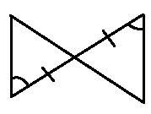 | 2)  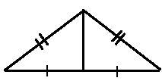
3)  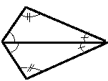 | 4)  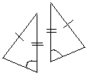
5) | 6)

