Name:______________________________________ **Unit 6 – Two-Column Proofs with Triangles**

Monica

Geometry Period:_____

Date:_______________________________

**Directions: Complete each proof below using the two-column method.**

1) 



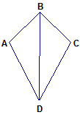

2) 



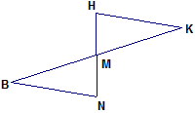

3) 



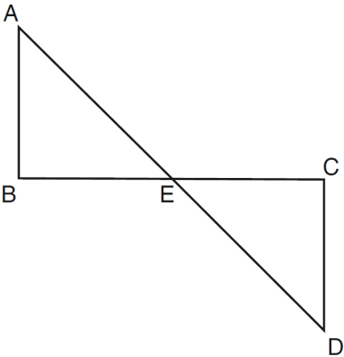

4) 



