Name:________________________________ **Unit 8 – Compound Locus**

Monica

Geometry Period:_____

Date:____________________________

|  |  |
| --- | --- |
| **Outcome** | **Rating** |
| 13: Identifies parts and properties of circles and can precisely determine measurements of area, circumference, arc length, angles, tangents, and secants | NY MS ES |
| 14: Writes, graphs and communicates equations of circles and can find the center and radius of a circle given the equation | NY MS ES |
| 17: Graphs, solves, and communicates problems using compound loci, including on a coordinate plane | NY MS ES |

**Directions:** Answer all of the questions below. Use dashed lines to indicate all loci. **USE PENCIL!!!**  You may use a compass to help your draw the locus, where appropriate.

1) A man wants to place a new bird bath in his yard so that it is 30 feet from a fence, *f*, and also 10 feet from a light pole, *P*. As shown in the diagram below, the light pole is 35 feet away from the fence. Sketch all of the possible locations for the bird bath. Label the locations with an X.

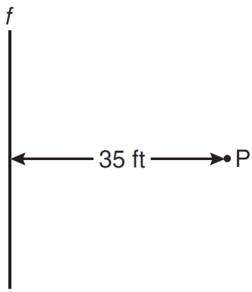

2) Towns *A* and *B* are 16 miles apart. How many points are 10 miles from town *A* and 12 miles from town *B*? Sketch a picture to support your claim.

3) Two lines, ** and **, are parallel and 10 inches apart. Sketch the locus of all points that are equidistant from ** and ** and 7 inches from point *R*. Label with an **X** each point that satisfies both conditions.

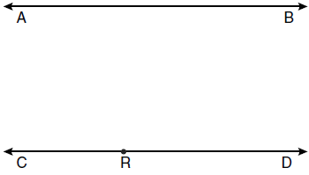

4) In the diagram below, point *M* is located on *.* Sketch the locus of points that are 2 units from and the locus of points 2 units from point *M.* Label with an **X** all points that satisfy both conditions.

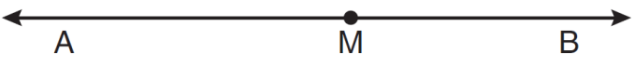

5) What is the locus of points 5 units from the point (-4, 6)? Write an equation to represent this locus.

6) In the diagram of circle O below, =, and. Determine the following:

a) 

b) 

c) 



7) Graph a circle on the coordinate plane below with the equation .

