Directions: Use the markers to sketch the locus of points for each scenario below.

- How many points are both 4 units from the origin and also 2 units from the line ? Sketch the locus on the coordinate plane below.
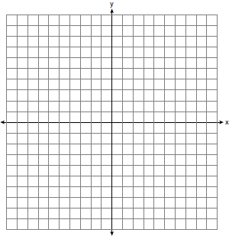

- On the grid below, graph the points that are equidistant from both the x and y axes and the points that are 5 units from the origin. Label with an X all points that satisfy both conditions.

- On the set of coordinate axes below, graph the locus of points that are equidistant from the lines and and also graph the locus of points that are 3 units from the y-axis. State the coordinates of all points that satisfy both conditions.

- On the set of axes below, graph the locus of points 4 units from and the locus of points 3 units from the origin. Label with an X any points that satisfy both condition.

