Name:_____________________________________ Unit 6 – Locus on a Coordinate Plane
Monica
Geometry Period:_____
Date:_______________________________

Outcome | Rating
#17: Graphs, solves, and communicates problems using compound loci, including on a coordinate plane | NY MS ES

Directions: Answer all of the questions below. Be sure to show all of your work. Use pencil!

1) In a coordinate plane, how many points are both 5 units from the origin and 2 units from the x-axis? Sketch a picture on the coordinate plane below.
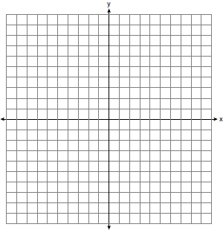

2) In the coordinate plane, what is the total number of points 5 units from the origin and equidistant from both the x- and y-axes? Sketch a picture on the coordinate plane below.

3) On the set of axes below, graph the locus of points 4 units from the x-axis and equidistant from the points whose coordinates are and . Mark with an X all points that satisfy both conditions.

4) A city is planning to build a new park. The park must be equidistant from school A at and school B at . The park also must be exactly 5 miles from the center of town, which is located at the origin on the coordinate graph. Each unit on the graph represents 1 mile. On the set of axes below, sketch the compound loci and label with an X all possible locations for the new park.

