Name:________________________________________ **Unit 6 – Proofs With Circles**

Monica

Geometry Period:____

Date:__________________________________

**Directions:** Complete all of the proofs below. You may use a paragraph proof or a two-column proof. For an ES, complete proofs #1 and #2 in TWO different ways.

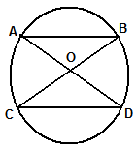

1) Given: Circle O



Prove: 

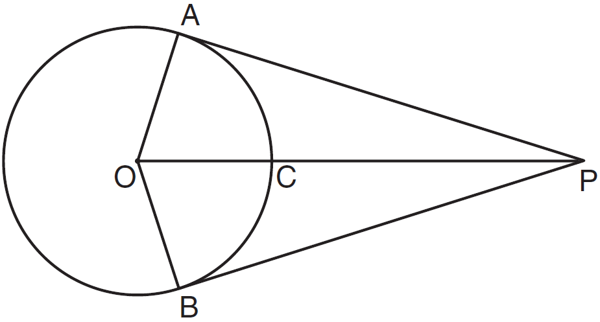

2) Given: Circle O

Tangents PA, PB

Radii OA, OB

Prove: 

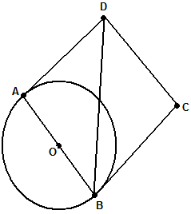

3) Given: Circle O





Prove: 

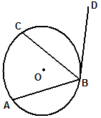

4) Given: Circle O

Chords 

C is the midpoint of 

Prove: 