**Today you will use Geometer’s sketchpad to explore the relationships among angles and side lengths in circles. This handout provides you with the necessary steps to follow to discover this information. COPY AND COMPLETE EACH ITALICIZED STATEMENT AND CORRESPONDING DIAGRAM into your notes. Record any formulas corresponding formulas.**

**The GSP file for this investigation can be accessed at geometry2014.weebly.com under “Unit 8 – Circles”. Open the file named “Day 2 GSP File – Properties of Circles.”**

**TAB #1:** Examine the relationship between and  . Copy and complete the statement below.

*A central angle is _____________ to the intercepted arc.*



**TAB #2:** Examine the relationship between  and  . Copy and complete the statement below.

*An inscribed angle is _____________ of the intercepted arc.*

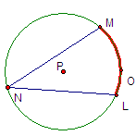

**TAB #3:** Look at the two intersecting chords. Examine the relationship of the angle formed by the chords () and the arcs intercepted by the chords (and ). Copy and complete the statement below.

*An angle formed by two intersecting chords is equal to ____________________________________.*



**TAB #4:** Examine the relationship of the angle formed by the radius and the tangent, . Copy and complete the statement below.

*A radius and a tangent that meet at the same point form a _________ angle.*



**TAB #5:** Examine the relationship of the arc () and angle () formed by an intersecting chord and tangent. Copy and complete the statement below.

*The measure of the angle formed by a chord and tangent is _________ of the intercepted arc.*



**TAB #6:** Examine the relationship of the two arcs (and ) and the angle () formed by the two tangents. Copy and complete the statement below.

*The measure of the angle formed by two tangents is equal to _________________________ of the intercepted arcs.*

**

**TAB #7:** Examine the relationship of the two arcs (and) and the angle () formed by the tangent and the secant. Copy and complete the statement below.

*The measure of the angle formed by a tangent and a secant is equal to _________________________ of the intercepted arcs.*



**TAB #8:** Examine the relationship of the two arcs (and) and the angle () formed by the two secants. Copy and complete the statement below.

*The measure of the angle formed by two secants is equal to _________________________ of the intercepted arcs.*



**TAB #9:** Examine the relationship of the two tangents from the same external point. Copy and complete the statement below.

*Two tangents to a circle from the same external point are ___________________.*

**

**TAB #10:** Examine the relationship of the lengths of the segments formed by two intersecting chords.Copy the diagram below into your notes and the corresponding formula: (NOTE: SEGMENTS ARE NAMED DIFFERENTLY THAN IN GEOMETER’S SKETCHPAD.)

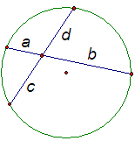

**TAB #11:** Examine the relationship of a tangent and secant from the same external point.Copy the diagram below into your notes and the corresponding formula showing the relationship of the side lengths: (NOTE: SEGMENTS ARE NAMED DIFFERENTLY THAN IN GEOMETER’S SKETCHPAD.)

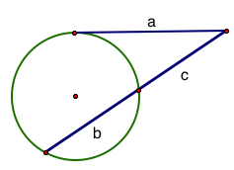

**TAB #12:** Examine the relationship of two secants from the same external point.Copy the diagram below into your notes and the corresponding formula: (NOTE: SEGMENTS ARE NAMED DIFFERENTLY THAN IN GEOMETER’S SKETCHPAD.)

