**BASIC PRACTICE CIRCLE QUESTIONS**

**Note: Pictures are NOT drawn to scale.**

1) In diagram 1, if = 50°, what is the 

2) In diagram 1, if = 80°, what is the 

3) In diagram 1, if , what is the measure of ?

4) In diagram 1, if , what is the measure of ?

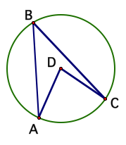



Diagram 3

5) In diagram 2, if = 74 and = 52, what is the measure of 

6) In diagram 2, if= 48 and , what is the measure of ?

7) In diagram 2, if BE = 7, ED = 8, and AE =14, what is the measure of CE?

Diagram 1

Diagram 2

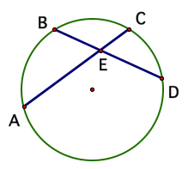

8) In diagram 3, radius AB and tangent are BC are drawn. If , what is the 

9) In diagram 4, chord DF and tangent DE are drawn. If = 130, what is 



Diagram 4

10) In diagram 5, secants CE and CA are drawn. If and , what is 

11) In diagram 5, secants CE and CA are drawn. If and , what is

12) In diagram 5, secants CE and CA are drawn. IF AC = 12, BC = 6, and CD = 8, what is the measure of CE?

13) In diagram 5, secants CE and CA are drawn. IF AB = 7, BC = 8, and CD = 5, what is the measure of DE?



Diagram 5

14) In the accompanying diagram of circle *O*, chords  and intersect circle at *E*, , , , and . Find *AE*.

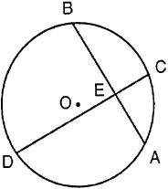

15) In the accompanying diagram,  and  are tangents drawn to circle *O*. If , find .

