Name:_______________________________________________ **Unit 8 – Locus Theorems**

Monica

Geometry Period:______

Date:______________________________________

**Directions:** Sketch the locus for each scenario. Use dashed lines to show each locus. Then, fill in the blanks to make each theorem complete.

|  |  |  |
| --- | --- | --- |
| **#** | **THEOREM** | **PICTURE** |
| 1 | The locus of points a fixed distance, *d*, from point *P* is a ____________________ with the given point *P* as its center and *d* as its radius. | Sketch the points *d* units away from point *P.*  *P* |
| 2 | The locus of points at a fixed distance, *d*, from a line, *l*, is a pair of __________________________________________ *d* distance from *l* and on either side of *l.* | Sketch the points *d* units away from line *l.*  *l* |
| 3 | The locus of points equidistant from two points, *P* and *Q*, is the ___________________________________________ of the line segment determined by the two points. | Sketch the points equidistant from points *P* and *Q.*  *P*  *Q* |
| 4 | The locus of points equidistant from two parallel lines,  and , is a _________________ parallel to both  and and midway between them. | Sketch the points equidistant from and . |
| 5 | The locus of points equidistant from two intersecting line,  and , is a pair of _________________________ that bisect the angles formed by  and . | Sketch the points equidistant from  and . |

PRACTICE!

1) Sketch the locus of point 3 units away from line *m*.

*m*

3) Sketch the locus of points 4 units from the point below.



2) Sketch the locus of point equidistant from the

intersecting roads 28th Avenue and 36th street, as

shown in the picture below.

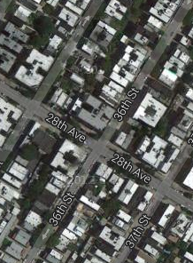

4) Sketch the locus of points equidistant from the points A and B below.

