Name:_____________________________________ **Unit 8 – Practice with Circles**

Monica

Geometry Period:____

Date:____________________________

|  |  |
| --- | --- |
| **Outcome** | **Rating** |
| #13: Identifies parts and properties of circles and can precisely determine measurements of area, circumference, arc length, angles, tangents and secants | NY MS ES |
| #14: Writes, graphs and communicates equations of circles and can find the center and radius of a circle given the equation | NY MS ES |

**Directions: Answer all of the questions below. You must show all of your work in order to receive full credit.**

1) In the diagram below, trapezoid *ABCD*, with bases  and , is inscribed in circle *O*, with diameter . If , find 

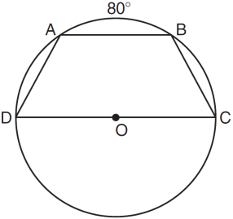

2) In the diagram below of circle *O*, radius  is 5 cm. Chord  is 8 cm and is perpendicular to  at point *P*.What is the length of , in centimeters?

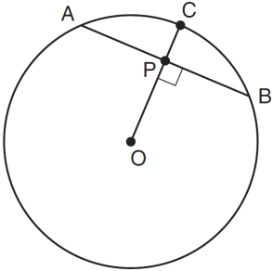

3) In the diagram below of ,  is tangent to circle *O* at point *A*, , and . What is the length of ?

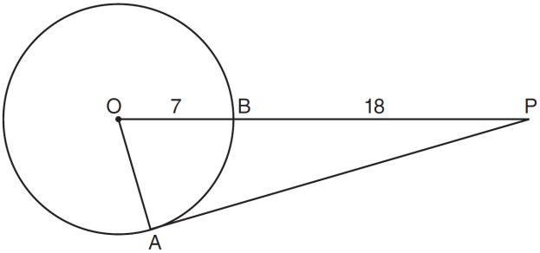

4) Tangents  and  are drawn to circle *O* from an external point, *P*, and radii  and  are drawn. If, what is the measure of ?

5) In the accompanying diagram of circle *O*, chords  and  intersect at *E* and . What is ?

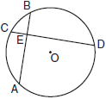

6) In the accompanying diagram of circle *O*,  and . Find the value of *x*.

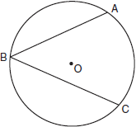

7) In the diagram below, tangent  and secant  are drawn to circle *O*. The ratio  is *.* Find .

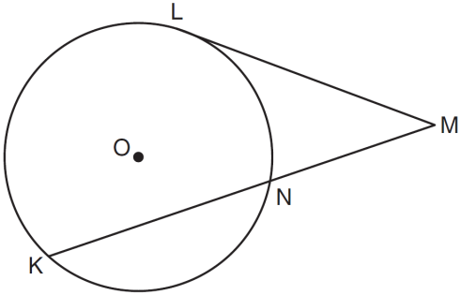

8) In the diagram below,  is circumscribed about circle *O* and the sides of  are tangent to the circle at points *D*, *E*, and *F*. If , , and , what is the length of ?

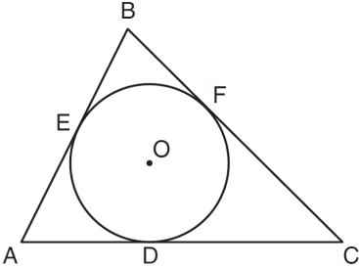

9) In the accompanying figure,  is tangent to circle *O* at *A*, and  is a secant. If  and , find *PA*.

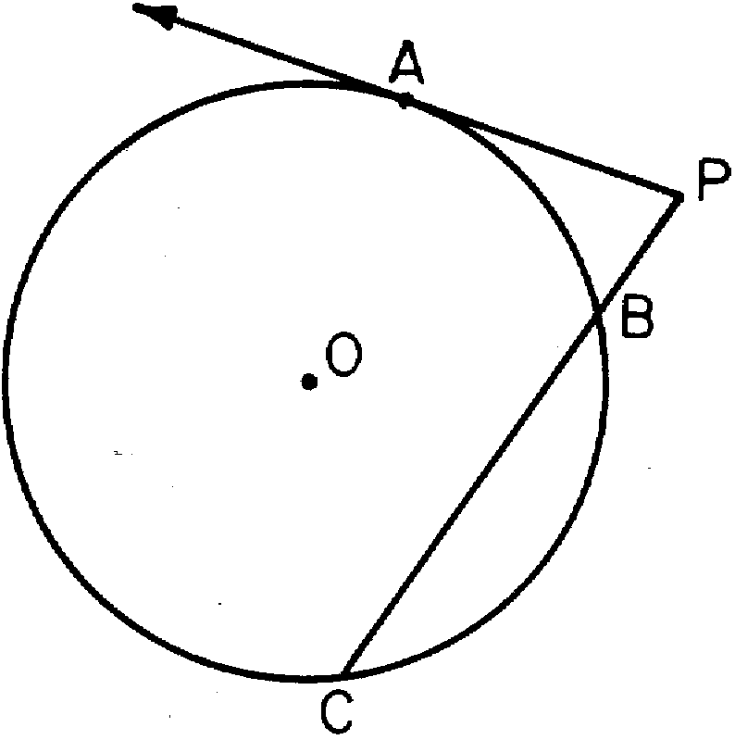

10) In the accompanying diagram of circle *O*, chords  and intersect at *E*. If , *, ,* and , what is the value of *x*?

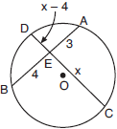

11) What is the equation of a circle whose center is (-5, 4) and has a radius of 7?

12) In the accompanying diagram, the center of circle *O* is , and the coordinates of point *P* are . If  is a radius, what is the equation of the circle?

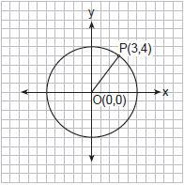

13) Graph  on the accompanying grid.

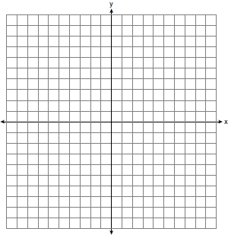

14) The endpoints of the diameter of a circle are (4, -3) and (8, 1). What is the equation of the circle?