Name:_____________________________________ **Unit 9 – Similar Figures**

Monica

Geometry Period:_____

Date:_________________________

**Directions:** Use your knowledge of similar figures to answer the questions below. In order to receive a “MS” rating, you must show all of your work.

1) In the accompanying diagram,  is similar to , , , , and . What is the length of ?

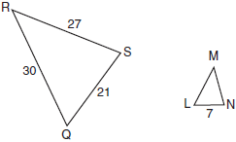

2) In the accompanying diagram, triangle *A* is similar to triangle *B*. Find the value of *n*.

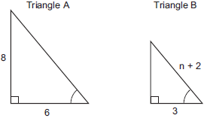

3) If , , , and , find . [Only an algebraic solution can receive full credit.]

4) As shown in the diagram below, , , , , and . What is the length of ?

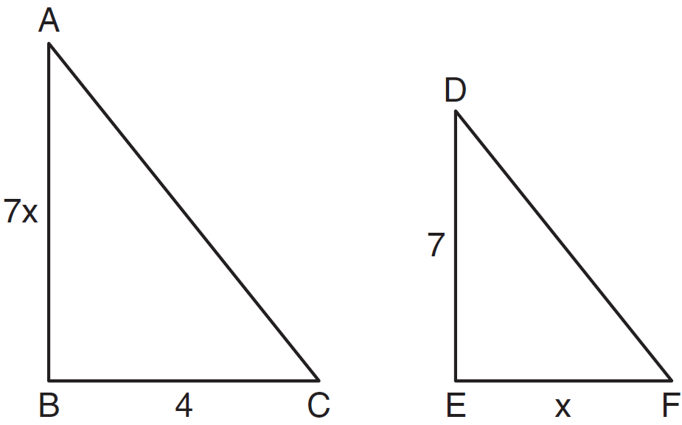

5) In the diagram below, , , , , and . Determine the length of **. [Only an algebraic solution can receive full credit.]

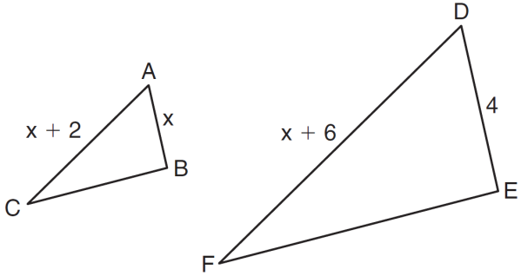

|  |  |
| --- | --- |
| 1) |  |
| 2) |  |
| 3) |  |
| 4) |  |

6) In the diagram below, .

Which statement is *not* true?

