Name:______________________________________ Unit 9 – HW – Proofs with Similar Triangles
Monica
Geometry Period:____
Date:_________________________

Outcome | Rating
#1: Argues with different types of reasoning in order to prove or disprove a statement | NY MS ES
#9: Discerns and applies concepts of similarity in two triangles or polygons | NY MS ES
#13: Identifies parts and properties of circles and can precisely determine measurements of area, circumference, arc length, angles, tangents and secants | NY MS ES

Directions: Complete the proofs below. You may use a paragraph proof or a two-column proof.

1) The diagram below shows , with , , and . Prove that is similar to .
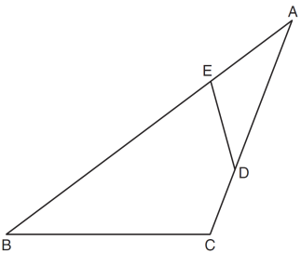

2) In the accompanying diagram of circle O, diameter is drawn, tangent is drawn to the circle at B, E is a point on the circle, and .
Prove:
