**Name:_______________________________________ Unit 9 – Proportions in Triangles**

**Period:______**

**Date:____________________**

|  |  |
| --- | --- |
| **Outcomes** | **Rating** |
| #1: Argues with different types of reasoning in order to prove or disprove a statement | **NY MS ES** |
| #9: Discerns and applies concepts of similarity in two triangles or polygons | **NY MS ES** |

**Directions Part 1:** Today you will be using GSP to explore proportions in triangles. Be sure to follow the steps carefully and copy the theorems into your notebook.

**STEP 1:** Draw .

**STEP 2:** Construct point D on 

**STEP 3:** Construct line DE parallel to . (To do this, select point D and . Then choose “Parallel Line” under the “Construct” menu. Label the point of intersection E.)

**STEP 4:** Measure  (To do this, select the endpoints of each segment and choose “Distance” under the “Measure” menu.)

**STEP 5:** Calculate the ratios  (To do this, select “Calculate” under the “Number” menu. Select the measurement for BD, then select the division symbol, then select the measurement for DA. Hit “OK”. Repeat this process for the other ratio.)

**STEP 6:** Drag various points to change the measurements of your segments. Observe how the ratios change.

**QUESTION #1: What do you notice about the ratios as you change the points? Why do you think this is the case?**

**QUESTION #2: Are there other ratios that are equivalent in this triangle? What are they?**

**Copy the diagram below into your notebooks. Complete the proportion below using the side lengths in the diagram based on what you discovered in step 5.** *NOTE: POINTS ARE NAMED DIFFERENTLY THAN THEY ARE IN GSP.*

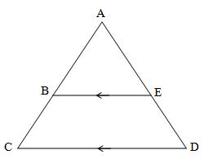



**Copy into your notes: SIDE-SPLITTER THEOREM: If a line cuts through a triangle so that it is parallel to one of the sides, it cuts the other two sides of the triangle proportionally.**

**STEP 7:** Open a new sketch. (To do this, select “New Sketch” under “File”.)

**STEP 8:** Draw .

**STEP 9:** Construct the angle bisector of . (To do this, select points C, A, and B, in that order, and choose “Angle Bisector” under the “Construct” menu.)

**STEP 10:** Label the point of intersection of the angle bisector and  as point D.

**STEP 11:** Measure 

**STEP 12:** Calculate the ratios 

**STEP 13:** Drag points A, B, and C to change the measurements of your segments. Observe how the ratios change.

**QUESTION #4: What do you notice about the ratios as you change these points?**

**COPY THIS IMAGE WITH THE CORRESPONDING RATIOS INTO YOUR NOTEBOOK. Be sure to label your diagram carefully.**

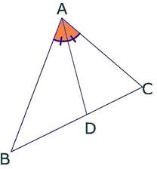



**Copy into your notes: ANGLE-BISECTOR THEOREM: An angle bisector of an angle of a triangle divides the opposite side in two segments that are proportional to the other two sides of the triangle.**

**DIRECTIONS PART 2:** Apply what you’ve learned today to answer the questions below.

1) In the diagram below of , , , , and . What is the length of ?

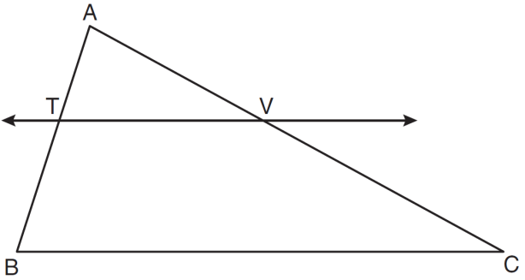

2) In the diagram below of , . If , , and , what is the length of ?

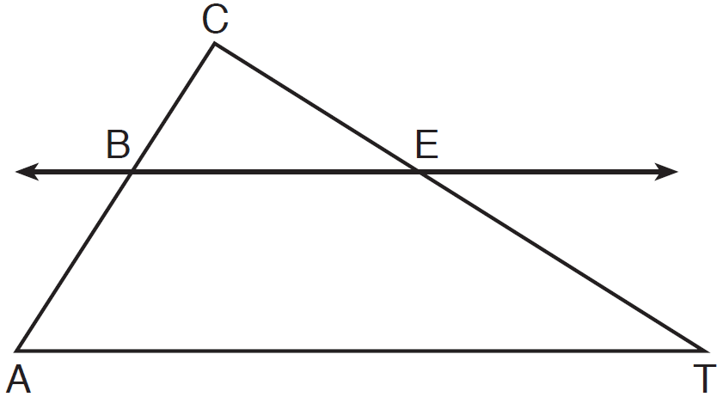

3) In the diagram below of , *B* is a point on  and *C* is a point on  such that , , , , and . Find the length of .

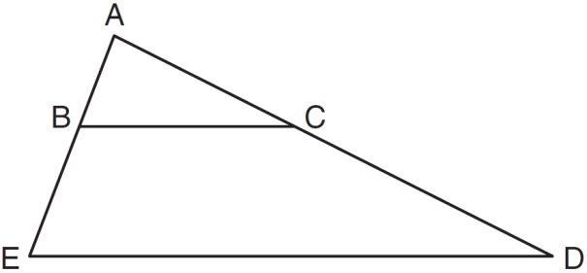

4) What is the length of AB in the triangle below? Round your answer to the nearest tenth.

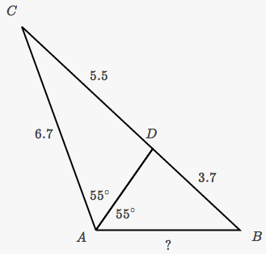

6) In , point *D* is on , and point *E* is on  such that . If , , and , what is the length of ?

7) In the diagram below of , *E* is a point on  and *B* is a point on , such that . If , , and , find the length of .

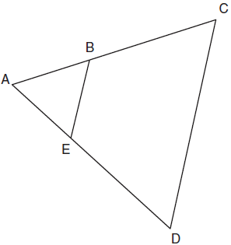

8) In the diagram below of , BD bisects,  What is the value of x? Classify .

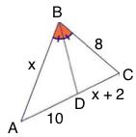

9) Maryam tried to solve the problem below by setting up the following proportion: $\frac{12}{8}=\frac{4.3}{x}$. Correct her mistake and set-up the correct proportion.

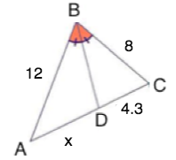

**ES:** Prove the Side-Splitter Theorem is true. You may use two-column or paragraph. Please submit on a separate piece of paper.